WD_BLACK C50 Storage Expansion Card for Xbox

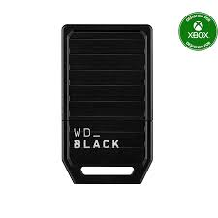

**Key Features**

* **Designed for Xbox**: Officially licensed by Xbox, ensuring compatibility and optimized performance.
* **Capacity Options**: Available in 512GB and 1TB versions, providing ample space for game installations.
* **Plug-and-Play Functionality**: Easy to install with no tools required; simply insert the card into the dedicated expansion slot.
* **Fast Load Times**: Matches the performance of the Xbox Velocity Architecture, enabling rapid load times and quick resume features.
* **Premium Performance**: Matches the speed and responsiveness of the internal SSD for a smooth gaming experience.
* **Compact and Durable Design**: Built for long-term use while maintaining portability.

Specifications

* **Interface**: Custom storage expansion slot for Xbox Series X|S.
* **Form Factor**: Compact and portable design.
* **Performance**: Supports the same high-speed gameplay experience as the internal SSD of Xbox Series X|S.

**Warranty**

* **Manufacturer's Warranty**: Backed by a **5-Year Limited Warranty**, ensuring peace of mind and reliable support